**Project Details**

|  |  |
| --- | --- |
| Project number | *12* |
| Project title | *Mega store corporation* |
| Corresponding TA\LA | *TA/Dina Abbas* |
| Deliverable | *2* |

**Team Details**

|  |  |  |
| --- | --- | --- |
| **Student ID** | **Student name** | **Lab Group** |
| 20200076 | Esraa Mohamed Abdel satar | S3 |
| 20201024 | Alaa essam ali | S5 |
| 20201202 | Norhan Hassan Ali Elsadiq | S7 |
| 20200618 | Hala Gamal Meselhy | S4 |
| 20200599 | Nagham hassan abu elfath | S7 |
| 20200093 | Omnya alaa korany | S8 |
| 20201178 | Mennat allah Mohamed Ibrahim el sharawy | S7 |

1. Use cases model:
   1. **Using Event Decomposition technique:**

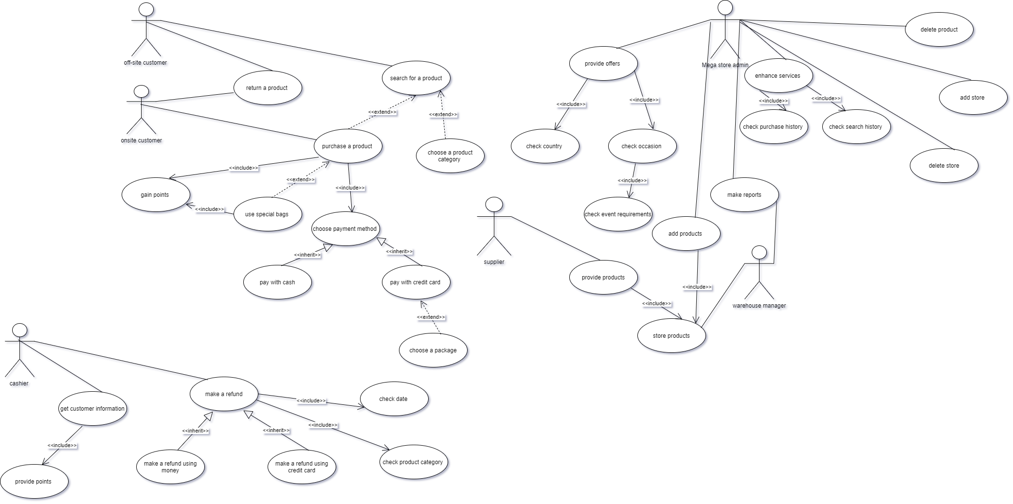

Table 1- Types of Events

* + 1. Types of Events

|  |  |
| --- | --- |
| Event | Type  (External/State/temporal) |
| Supplier provides different products to the system | External event |
| Mega store stores products in its own warehouses or rented warehouses per country | State event |
| Customer buy product through off-site services either through store websites per country or a mobile application customized per user location | External event |
| Customer buy product through on-site services which allow the customers to buy from a physical location. | External event |
| System provides points to the customer when using special bags | State event |
| Customer uses special bags. | External event |
| Customer chooses the suitable payment method while purchasing | External event |
| System provides points to the customer per purchase operation | State event |
| The points are affected by special offers announced for a limited time | Temporal event |
| Make reports about products | External event |
| Adding product to system | State event |
| delete products from the system | State event |
| Add store or hypermarket to be joined to mega store corporation | State event |
| Delete store or hypermarket from mega store corporation | State event |
| Offers differ throughout the year that vary with the occasion | Temporal event |
| Offers van differ per country and payment method | State event |
| Customers can return specific products while following the system’s return policy | External event |
| System will return customer’s money if the customers follows the system’s return policy | Internal event |
| Customer can search for a product | External event |
| Mega store admin will enhance system service through search and purchase history | Internal event |
| Customer purchase a product | External event |
| Mega store admin will enhance system service | Internal event |

* + 1. Formalize events with use cases

Table 2- Formalizing Events to use cases

|  |  |  |
| --- | --- | --- |
| Event | Type  (External/State/temporal) | Use case |
| Supplier provides different products to the system | External event | Provide products |
| Mega store stores products in its own warehouses or rented warehouses per country | State event | Store products |
| Customer buy product through off-site services either through store websites per country or a mobile application customized per user location | External event | Buy Product by off-site way |
| Customer buy product through on-site services which allow the customers to buy from a physical location. | External event | Buy Product by on-site way |
| System provides points to the customer when using special bags | State event | Get points |
| Customer uses special bags. | External event | Use special bags |
| Customer chooses the suitable payment method while purchasing | External event | Make reports |
| System provides points to the customer per purchase operation | State event | Add product |
| Delete products from the system | State event | Delete product |
| Add store or hypermarket to be joined to mega store corporation | State event | Add store |
| Delete store or hypermarket from mega store corporation | State event | Delete store |
| Add offers to system | State event | Add offers |
| System provides points to the customer per purchase operation | State event | 1. Purchase a product 2. Gain points |
| The points are affected by special offers announced for a limited time | Temporal event | Gain points |
| Offers differ throughout the year that vary with the occasion | Temporal event | Provide offers |
| Offers van differ per country and payment method | State event | Provide offers |
| Customers can return specific products while following the system’s return policy | External event | Returning a product |
| System will return customer’s money if the customers follows the system’s return policy | Internal event | Make refund |
| Customer can search for a product | External event | Search for a product |
| Mega store admin will enhance system service through search and purchase history | Internal event | Check search history , check purchase history |
| Customer purchase a product | External event | Purchase a product |
| Mega store admin will enhance system service | Internal event | Enhance services |

* + 1. Use case Descriptions:

Table 3 - Use cases descriptions

|  |  |  |
| --- | --- | --- |
| Use case name | Actor | Description |
| Provide products | Supplier | -The mega store corporation communicates with different suppliers per country  -Supplier provide products  So, mega store representative transfers them to either own warehouses or rented |
| Store products | Warehouse manager | the mega store corporation store products came from suppliers per country to its own warehouses or rented ones. |
| Buy Product by off-site way | Customer | customer use website of his country or mobile application customized of his/her location  To be able to buy products by this way  -so, mega store gave the customer special bags |
| Buy Product by on-site way | Customer | Customer buy products by going to physical location of stores |
| Add product | Mega store admin | When products were delivered and stored to warehouses,  Mega store admin adds these products to system and mark them as available |
| Make reports | Mega store admin  Warehouse manager | Mega store admin informs warehouse manager of missing products, and warehouse manager tell mega store admin about available products |
| Delete product | Mega store admin | Mega store admin deletes product from system to label it as unavailable to customer to buy |
| Add store/hypermarket | Mega store admin | Mega store admin adds store or hypermarket from system to label it as available to the mega store corporation |
| Delete store | Mega store admin | Mega store admin deletes store or hypermarket from system to label it as unavailable to the mega store corporation |
| Add offers | Mega store admin | Mega store admin adds offers to system for people who have points when using special bags |
| Gain points | Customer | Customer purchases a product .Either he buys it using the application and uses special bags so, it adds points to his account's wallet, or he is buying the product from the store then the Cashier will provide him a coupon of points. |
| Provide offers | Mega store admin | Mega store admin decides the offers according to the occasion, country and payment method |
| Check occasion | Mega store admin | Mega store admin checks whether the occasion is local or global |
| Check event requirements | Mega store admin | Mega store admin checks event requirements as needs are changeable according to the occasion |
| Check country | Mega store admin | Mega store admin checks customer`s country as offers are changeable from country to another |
| Search for a product | Customer | Customer can search for the item he wants by investigating different partitions of store which contain a different kind of categories and this can be done on-site, while it can also be done off-site through searching on product that customer needs through online services (website or mobile application) |
| Purchase a product | Customer | Customer can go directly to the categories he wants, to purchase the product he wants from the store (on-site service) otherwise, a customer could also purchase a product directly by searching for it or going to the category where it belongs and purchasing it. |
| Enhance service | Mega store Admin | Admin will try to enhance system services by many ways to improve system performance through knowing Customer interests to make suggestions then for him |
| Check purchase history | Mega store Admin | Admin will check the products which was purchased before by the customer |
| Check search history | Mega store Admin | Admin will check the search history of customer to know more about his interests |
| Return a product | Customer | Customer have to ability to return a product through different return system policies |
| Check date | Cashier | System will check the date on which the customer have purchased the product |
| Check product categories | Cashier | System will check the product categories there are products that can be returned on the same day eg.(fresh food , dairy and pastry) other categories such as appliances can be returning within 14 days only |
| Make refund | Cashier | System will return the money back to the customer after checking date and the category of product |
| Return money by cash | Cashier | Customer will get his money back as cash ,this is can be done off-site through communicating with sales representative or if its on-site ,he will get it back directly from the casher |
| Return money with credit card | Cashier | Customer will get his money back through credit card in both ways whether its on-site or off-site |
| Get customer information | Cashier | Casher will get customer information such as name , phone ,order, order number |
| Provide points | Cashier | Casher will provide points to the customer based on the order the customer have choosed |

* + 1. Matrix that maps all domain classes to the set of use cases

|  |  |  |  |  |  |
| --- | --- | --- | --- | --- | --- |
| Use case  **Vs.**  Domain Class | Domain Class 1 | Domain Class 2 |  |  |  |
| Provide products | Product | supplier |  |  |  |
| Store products | Warehouse | product |  |  |  |
| Buy Product | customer | product |  |  |  |
| Gain points | Customer | Purchase |  |  |  |
| Make reports | Product |  |  |  |  |
| Add product | Product |  |  |  |  |
| Delete product | Product |  |  |  |  |
| Add store | Store |  |  |  |  |
| Delete store | Store |  |  |  |  |
| Add offers | Offers |  |  |  |  |
| Provide offers | Offers |  |  |  |  |
| Check occasion | Offers |  |  |  |  |
| Check event requirements | Offers |  |  |  |  |
| Check country | Offers |  |  |  |  |
| Search for a product | product |  |  |  |  |
| Purchase a product | purchase |  |  |  |  |
| Enhance service | Mega store services |  |  |  |  |
| Check purchase history | Mega store services |  |  |  |  |
| Check search history | Mega store services |  |  |  |  |
| Return a product | product |  |  |  |  |
| Check date | Cashier |  |  |  |  |
| Check product categories | Cashier |  |  |  |  |
| Make refund | Cashier |  |  |  |  |
| Return money by cash | Cashier |  |  |  |  |
| Return money with credit card | Cashier |  |  |  |  |
| Get customer information | Cashier |  |  |  |  |
| Provide points | Cashier |  |  |  |  |

**-Draw.io tool was used for designing use case diagram**